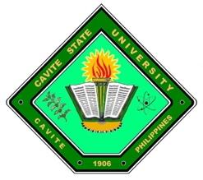
Republic of the Philippines
CAVITE STATE UNIVERSITY NAIC
(Formerly CAVITE COLLEGE OF FISHERIES)
Bucana Malaki, Naic, Cavite
www.cvsu-naic.edu.ph

INFORMATION TECHNOLOGY DEPARTMENT

REQUEST FOR ADVISER AND TECHNICAL CRITIC

NAME/S:_CANALES, MARC SAMUEL D., CRUDA, CARL EMMANUEL T., DE LA ROSA, JIREH CHRISTOPHER F._
COURSE:__BACHELOR OF SCIENCE IN COMPUTER SCIENCE_

SECTION:_BSCS 3A_

I formally agree and bind myself to be the Thesis Adviser or Technical Critic of the above-mentioned students. By affixing my signature, I am aware of the responsibilities and duties as a Thesis Adviser or Technical Critic and will such obligations to the best of my knowledge and abilities.

CONFORME:

__________________________ ____________ ________________________ ___________
Adviser Date Technical Critic Date

Approved by:

RICKY JAY A. RIEL, DIT
Research Coordinator and Chairperson, IT Department

